Technology Stack – Smart Sorting

# Technical Architecture

The system is composed of a Flask web interface, image preprocessing logic, and a CNN-based classification model (VGG16).

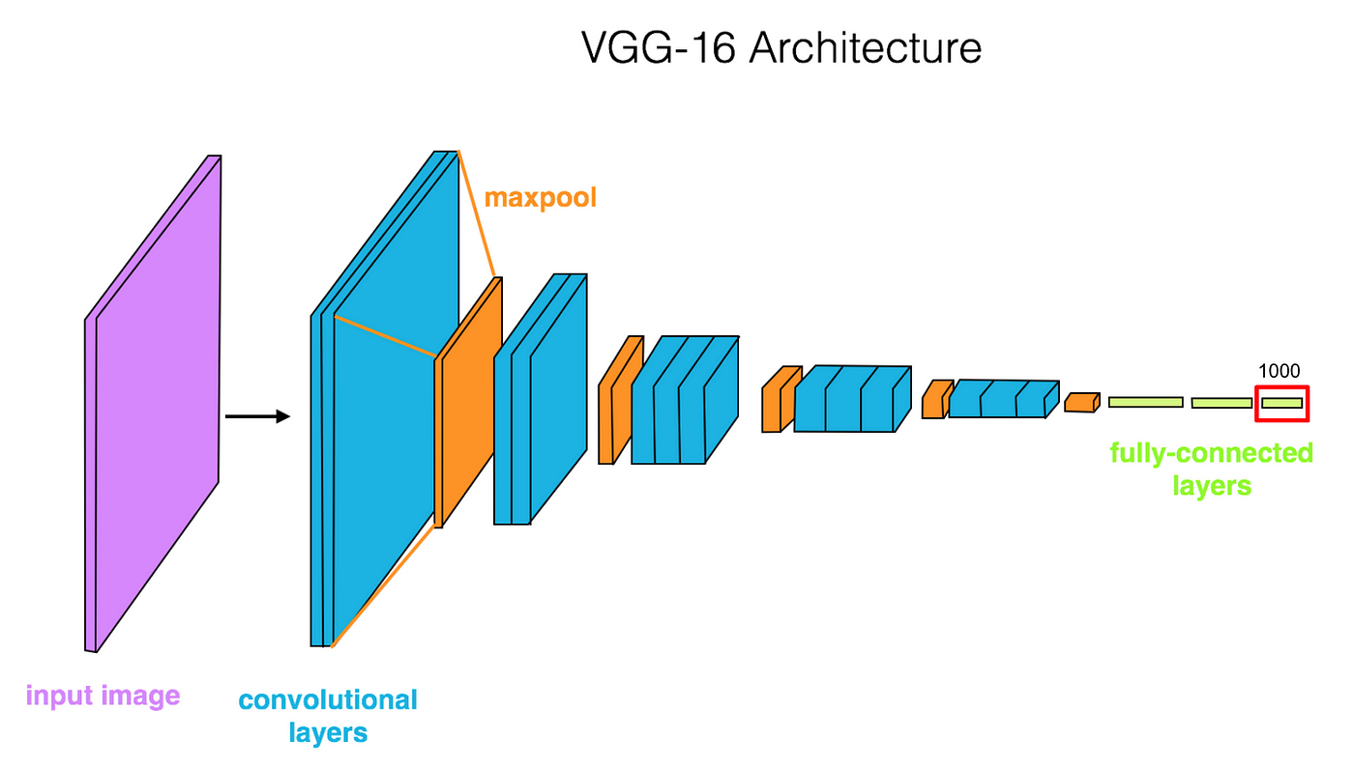

Figure 2: Technical Architecture of Smart Sorting

# Components & Technologies

|  |  |  |
| --- | --- | --- |
| Component | Description | Technology |
| User Interface | Web interface for image upload | HTML, CSS, Flask |
| Application Logic | Image processing and prediction | Python, OpenCV |
| ML Model | CNN-based classifier | TensorFlow, Keras (VGG16) |
| Database | Optional – store image logs | SQLite / Firebase |
| Deployment | Local or Cloud | Heroku / AWS / Local Server |